Lean Specification

Conversion - O2_GENAI_CNV404

Fleet Data (Asset) Corp Book Conversion From Vision To Oracle

Document Control Information

Document Information

|  |  |
| --- | --- |
| Document Identification | O2_GENAI_CNV404 |
| Document Name | O2_GENAI_CNV404_Fleet Data (Asset) Corp Book Conversion From Vision To Oracle |
| Project Name |  |
| Client | Client XXX |
| Document Author | Shubham Meghwal |
| Document Version | 1.0 |
| Document Status | Draft |
| Date Released |  |

Document Edit History

| Version | Date | Additions/Modifications | Prepared/Revised by |
| --- | --- | --- | --- |
| 1 |  | Initial Draft | Shubham Meghwal |
|  |  |  |  |
|  |  |  |  |

Document Review/Approval History

| Date | Name | Organization/Title | | Comments |
| --- | --- | --- | --- | --- |
| < dd-mmm-yyyy > | <Name> | | <Organization/Title> | <Comments> |
|  |  | |  |  |
|  |  | |  |  |

Distribution of Final Document

The following people are designated recipients of the final version of this document:

| Name | Organization/Title |
| --- | --- |
| <Name> | <Organization/Title> |
|  |  |
|  |  |

Table of Contents

1 Summary 4

1.1 Objective 4

1.2 Assumptions 4

1.3 Proposed Process 4

1.4 Dependencies and Prerequisites 5

2 Functional Design 6

2.1 Data Mapping Layout 6

2.2 Cross Reference/Data Transformation 6

2.3 Business Rules 6

2.4 Data Criteria Specifications 8

2.4.1 Data Selection and Filtering Criteria 8

2.4.2 Pre Extract Clean up Criteria 9

2.4.3 Post Extract Clean up Criteria 9

2.4.4 Pre Conversion Clean-up Criteria 9

2.4.5 Post Conversion Acceptance Criteria 9

2.4.6 Non-Converted Data 9

2.5 Acceptance Criteria 9

2.6 Test Scenarios 9

3 Technical Specification 10

3.1 Process Description 10

3.2Design Approach 10

3.3 Data Selection Criteria 10

3.4 File Layout / Report Output 10

3.5 Data Processing / Derivation / Validation / Transformation Rules 10

3.6 Validation & Reconciliation 10

3.6.1 Data Validation 10

3.6.2 Data Reconciliation 10

3.6.3 Post-conversion Steps 11

3.7 Component List 11

4 Application Setup and Technical Requirements 12

4.1 Programs/Report and Parameters 12

4.2 ESS Program, Scheduling and Executables 12

4.3 Security and Controls Requirements 12

4.4 Archiving & Purging 12

5 Open and Closed Issues 13

5.1 Open Issues 13

5.2 Closed Issues 13

6 Appendix 14

# Summary

## Objective

This functional design document is intended to provide the developer all the key information, rules, assumptions, and logic that are required to accurately outline the scope, scenario, and criteria for the Fixed Assets Corporate Book Conversion to efficiently convert the relevant data from legacy source systems VISION to the future state system Oracle Fixed Assets.

## Assumptions

* All in-progress asset transfers will be completed
* FA subledger period should be closed in source system
* Fixed asset is reconciled with general ledger in legacy system
* All vehicle attributes will be updated in the legacy system as appropriate before conversion

## Proposed Process

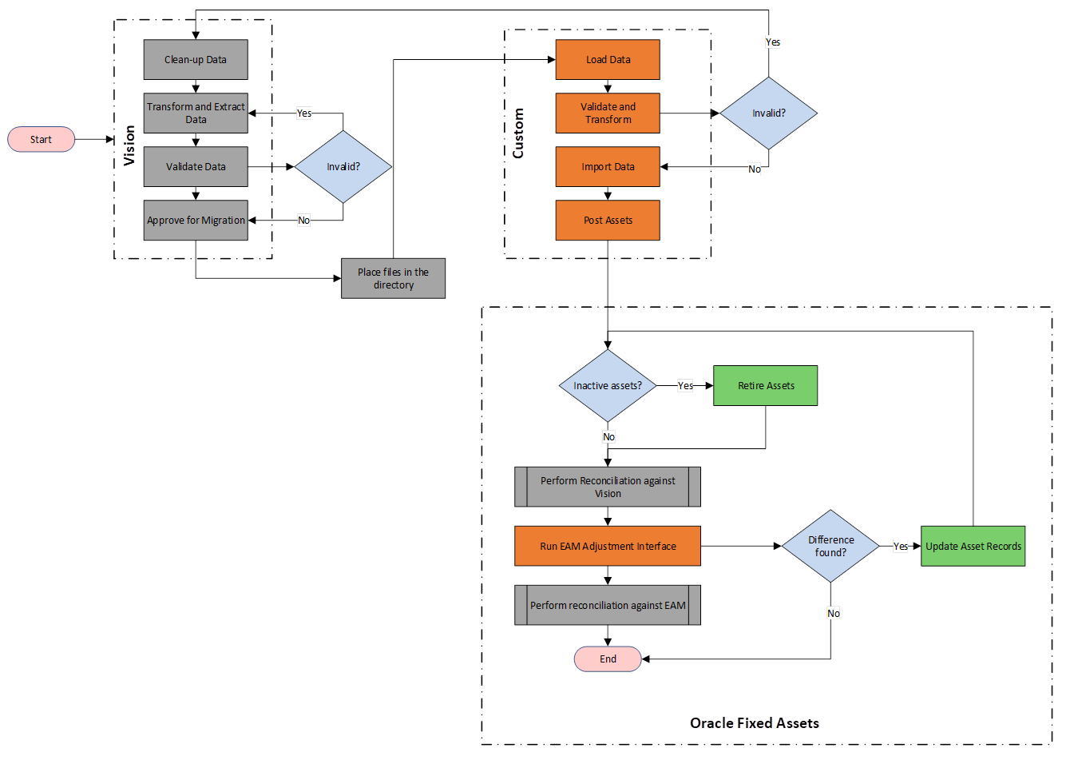

## Dependencies and Prerequisites

N/A

# Functional Design

## Data Mapping Layout

N/A

## Cross Reference/Data Transformation

N/A

## Business Rules

|  |  |
| --- | --- |
| Business Rules Rule ID | Description |
| BR01 | Extracted data from VISION needs to be validated and approved by the business before conversion. |
| BR02 | Major and Minor category needs to be provided by the business for each asset. |
| BR03 | Load will be executed with validation of data before conversion. All valid assets should be eligible for import into mass addition table. Failing validation, the asset data needs to be corrected as applicable in the VISION and provided again for reprocess. |
| BR04 | Active and Inactive assets will be converted separately. |
| BR05 | Inactive assets from VISION will be converted in the prior period of the go-live. Inactive assets will be converted prior to the Active Assets. Post conversion,   1. These assets will be loaded as active and retired in Oracle FA programmatically 2. Asset adjustment interface program will not be required to run for these assets 3. Reconciliation will be performed by the business post conversion against VISION 4. Depreciation program will be run, and the period will be closed in FA 5. The journals will be created and transferred to GL   These journals will be posted and then reversed in GL to ensure the GL trial balance is intact  The Inactive Assets will be first uploaded using the Mass Additions FBDI and then Retired using the Retirement FBDI.  Oracle Standard FBDI for Mass Additions will be used to create the Inactive Assets. A sample of the FBDI to be used is as below: -    Oracle Standard FBDI for Mass Retirement will be used to retire the Inactive Assets. A sample of the FBDI to be used is as below: - |
| BR06 | Active assets including CIP, capitalized and Leases will be converted in the period of the go-live. Active Assets will be converted post Inactive Assets. Post conversion,   1. Converted data will be reconciled against the VISION data by the fleet accounting business team 2. Asset adjustment interface will be executed to ensure the vehicle attributes are updated by Infor 3. Business will reconcile the vehicle details against Infor data   Addition journals to be reversed in GL |
| BR07 | Conversion will be executed only for fleet corporate books as configured in the lookup *XX_FA_FLEET_CORP_BOOKS*. |
| BR08 | YTD depreciation amount will be updated as accumulated depreciation for the current fiscal year, else it will be updated as 0 |
| BR09 | Asset categories in the file will have both major and minor segments concatenated with a separator “- “. E.g., FLEET-CAR, where FLEET is the major category and CAR is the minor category. |
| BR10 | Depreciate flag needs to be populated based on the category definition |
| BR11 | Vehicle delivery date in the asset file should be the In-service date for every asset. |
| BR12 | In-service date in the asset file should be the effective date of source line for the primary asset record. |
| BR13 | LKE eligibility flag for US assets will be populated to “Y” or “N” as provided in the extract. If no value found for any asset, the flag will be defaulted as “N” |
| BR14 | Capitalized flag should be updated to “Y” for all capitalized assets and “N” for all expensed assets. |
| BR15 | Retirement type for inactive assets shall be the below: -  - Conversion Write-offs |

## Data Criteria Specifications

### Data Selection and Filtering Criteria

* All the active assets will be extracted with their source line details for each country as applicable
* Retired or inactive assets will be extracted separately from the legacy system with the retirement details
* XXX Inactive asset extracts will be provided in FBDI file
* For converting valid data, the data needs to be provided in a format consistent with the requirements for uploading to the Oracle Fixed Assets application.
* The data attributes marked as “required” in the data mapping template in the other section will need to be reviewed for completeness in the extract.
* Missing or incorrect data should be updated or added in the legacy application and a new extract will be pulled.
* Validate for the leading and trailing spaces in the Oracle staging table for all columns.
* Validate all mandatory fields and have business correct in case of incorrect or null values.

### Pre Extract Clean up Criteria

N/A

### Post Extract Clean up Criteria

N/A

### Pre Conversion Clean-up Criteria

N/A

### Post Conversion Acceptance Criteria

N/A

### Non-Converted Data

N/A

## Acceptance Criteria

N/A

## 2.6 Test Scenarios

N/A

# 3 Technical Specification

## 3.1 Process Description

N/A

## 3.2Design Approach

N/A

## 3.3 Data Selection Criteria

N/A

## 3.4 File Layout / Report Output

N/A

## 3.5 Data Processing / Derivation / Validation / Transformation Rules

N/A

## 3.6 Validation & Reconciliation

### 3.6.1 Data Validation

N/A

### 3.6.2 Data Reconciliation

|  |  |
| --- | --- |
| S. No. | Actions to be performed |
| 1. | Reconcile record counts of all records extracted and made available to Oracle against the record counts of all records transformed using the data transformation rule. Ensure that the two counts match. |
| 2. | XXX Fleet Accounting business team will review the converted asset details against the VISION data |
| 3. | XXX Fleet Accounting business team will review the converted asset vehicle attributes against that in the EAM. |
| 4. | Ad-hoc reports will be created to extract data from Oracle FA, based on business user’s requirement, post conversion. |

### 3.6.3 Post-conversion Steps

* **Inactive Assets [Retired Assets]**

1. Reconcile data against VISION.
2. Run depreciation and close period.
3. Run Create Accounting and transfer journals to GL.
4. Post and reverse the journals in GL created as a part of conversion

* **Active Assets [Capitalized/Leased Assets]**
* Reconcile the converted data from Oracle against the VISION data for each book.
* Run the asset adjustment interface from EAM.
* Reconcile the assets and vehicle attribute details against EAM data

## 3.7 Component List

N/A

# 4 Application Setup and Technical Requirements

## 4.1 Programs/Report and Parameters

N/A

## 4.2 ESS Program, Scheduling and Executables

* **ESS Job -** **Load Interface File for Import**

**N/A**

## 4.3 Security and Controls Requirements

|  |  |  |
| --- | --- | --- |
| **Security/Control ID** | **Description** | **Comments** |
|  |  |  |
|  |  |  |
|  |  |  |

## 4.4 Archiving & Purging

N/A

# 5 Open and Closed Issues

## 5.1 Open Issues

|  |  |  |  |  |  |
| --- | --- | --- | --- | --- | --- |
| Date Reported | Status | Question | Resolution | Due Date | Responsible Party |
| 22-06-2023 | Open | Frequency to be updated |  |  | Deloitte |
| 22-06-2023 | Open | Retirement FBDI to be updated with Sample data upon finalization |  |  | Deloitte |

## 5.2 Closed Issues

N/A

# 6 Appendix

N/A